Table S5. Yield parameters of the Enrosadira variety (2023).
Combination | Yield of 1 plant (g) | Fruits per plant  (pcs.) | Fruit weight  (g)
Control | 316.18 ab | 76.52 ab | 4.13 ab
Animal Amino Acids | 293.64 b | 73.33 b | 4.00 ab
Plant Amino Acids | 375.90 a | 87.80 a | 4.28 a
Seaweed | 329.69 ab | 84.86 ab | 3.88 b
Seaweed + Amino Acids | 343.50 ab | 81.60 ab | 4.21 a
p-value | 0.016 | 0.043 | 0.008

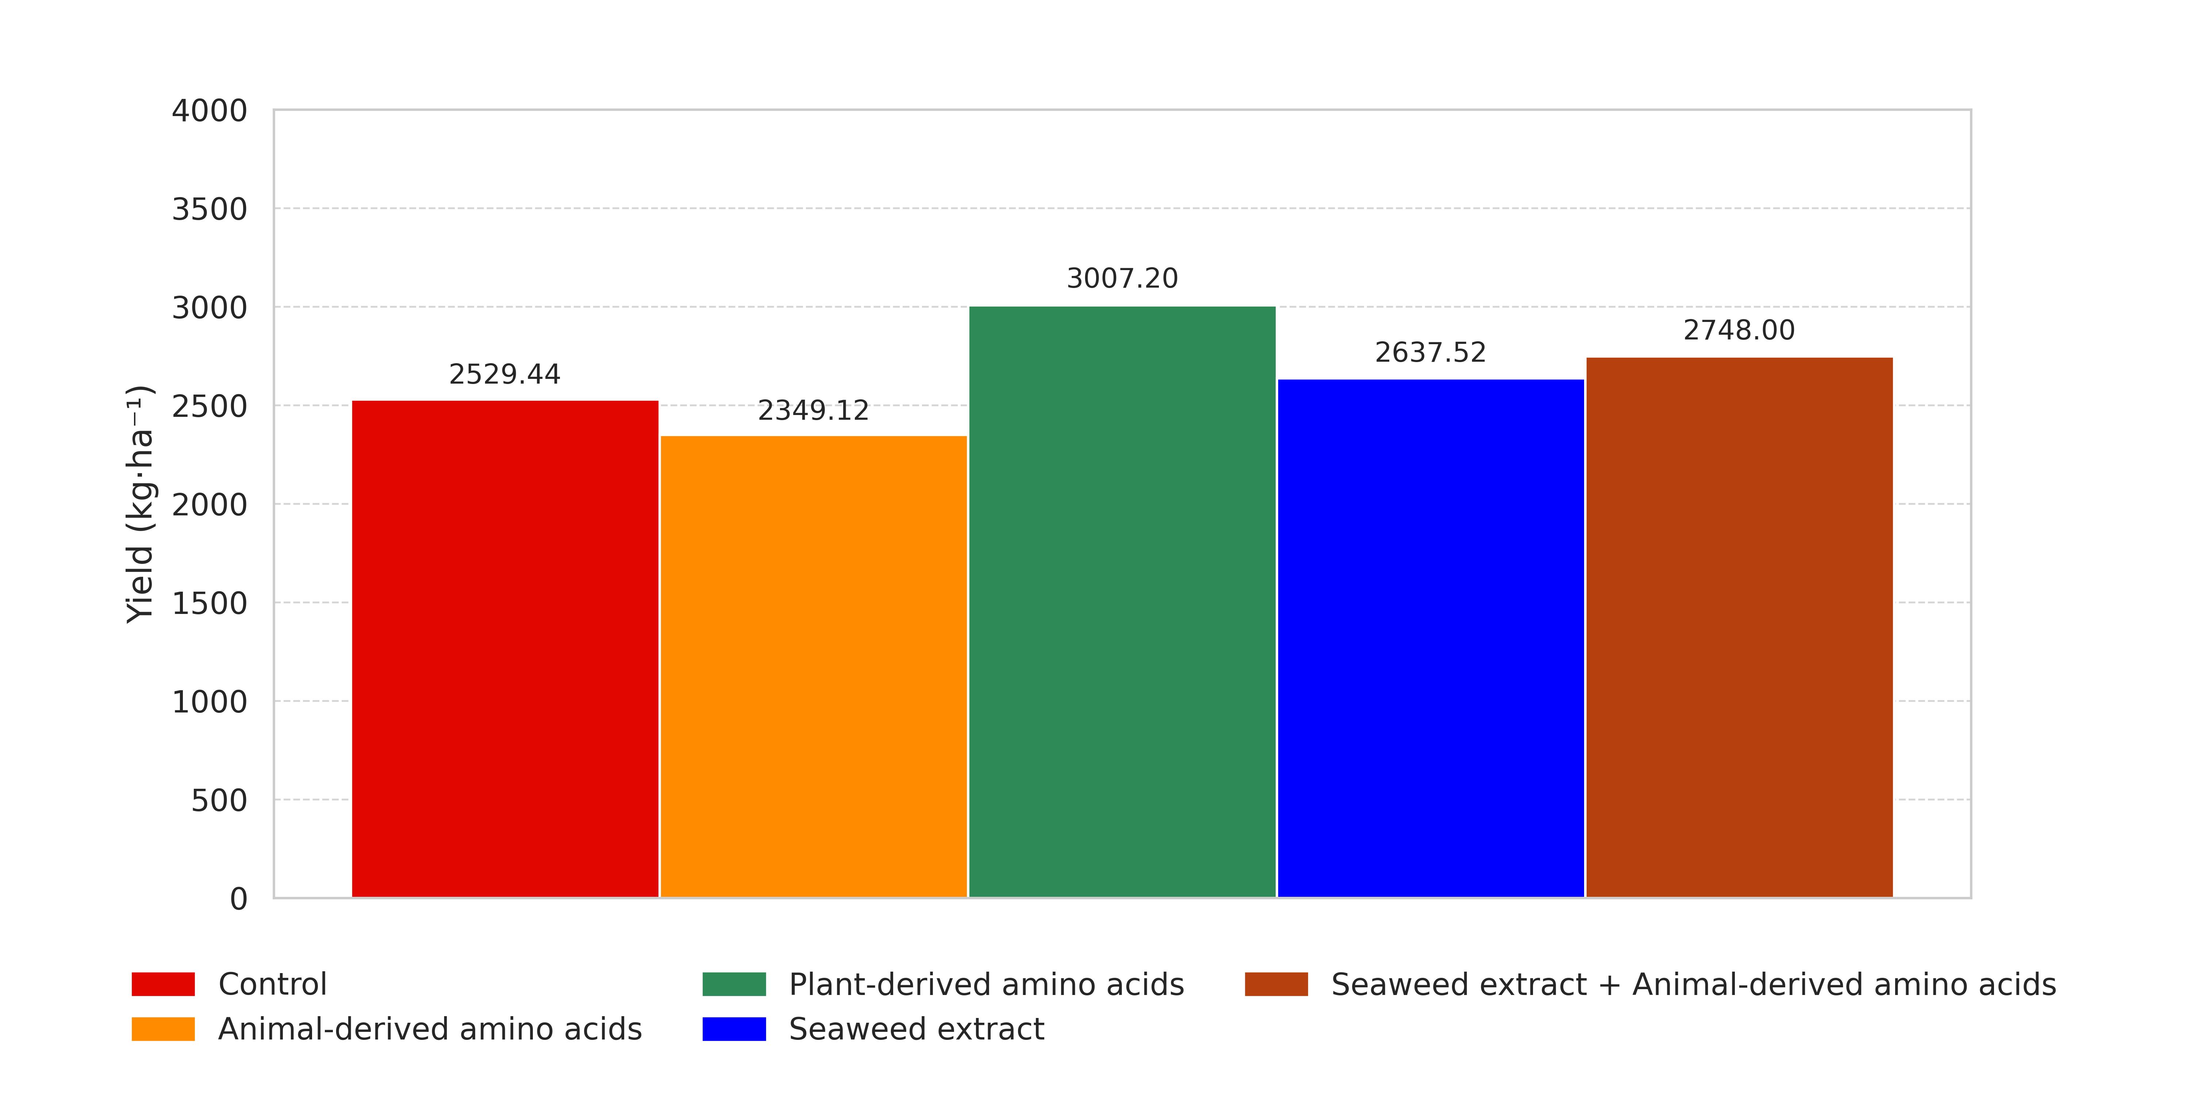
Figure S1. Yield per hectare for the Enrosadira variety (2023).

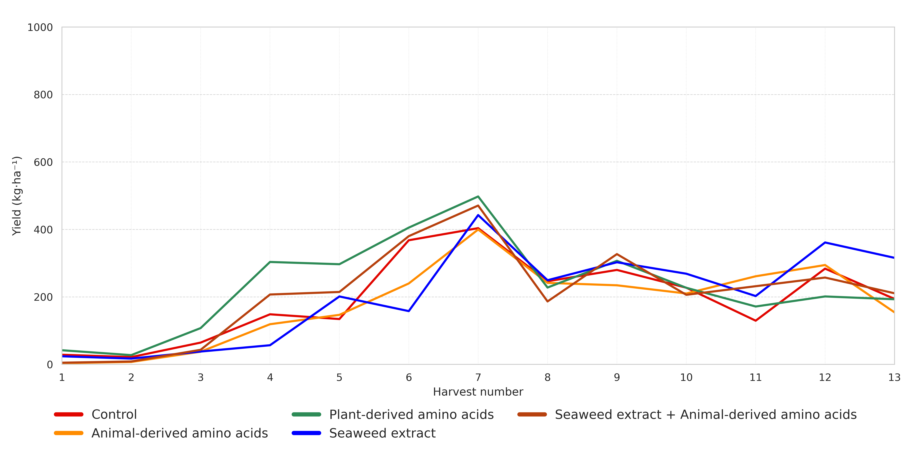
Figure S2. Yield per hectar depends on harvest for the Enrosadira variety (2023).
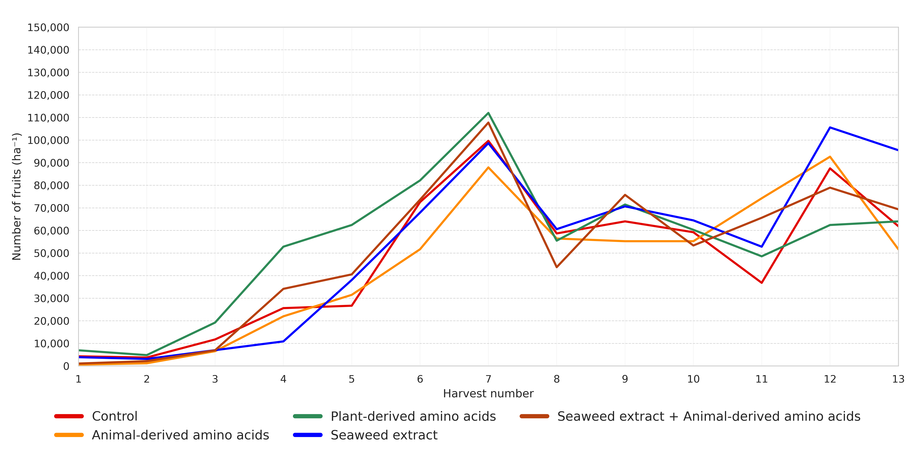
Figure S3. Number of fruits per hectar depends on harvest for the Enrosadira variety (2023).

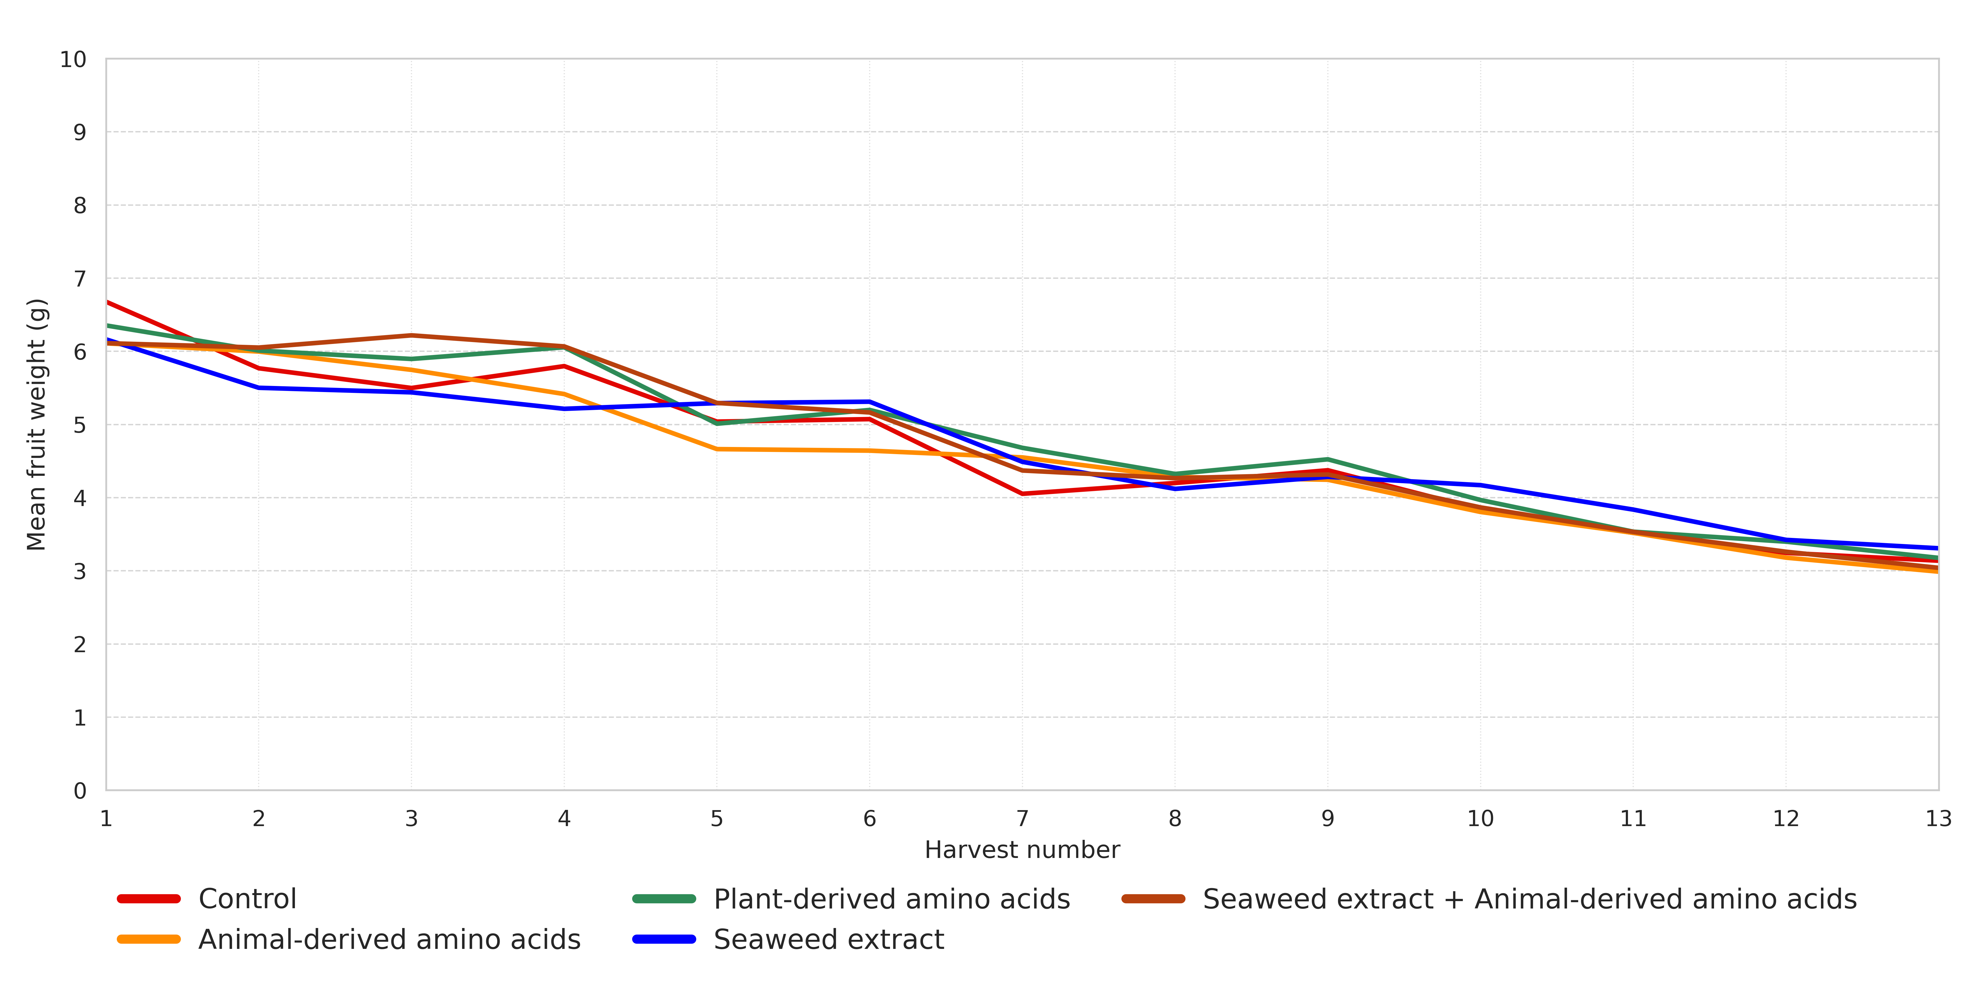
Figure S4. Mean fruit weight depends on harvest for the Enrosadira variety (2023).

Table S6. Growth parameters of the Enrosadira variety (2023).
Combination | Dormant buds  (pcs.) | Side branches (pcs.) | Average length  (cm) |  |  | Cane diameter at a height (mm)
 |  |  | Fruiting part | Non-fruiting part | Total | 0 cm | 60 cm | 120 cm
CT | 22.39 ab | 14.39 ab | 55.33 a | 103.17 bc | 158.50 a | 12.83 a | 9.22 a | 6.00 a
AAA | 23.78 b | 13.94 a | 54.22 a | 106.11 c | 160.33 a | 13.06 a | 8.78 a | 6.39 ab
PAA | 21.61 a | 15.22 b | 58.83 a | 98.39 a | 157.22 a | 13.39 a | 9.22 a | 6.83 b
SW | 22.28 ab | 15.00 b | 56.28 a | 101.61 abc | 157.89 a | 13.39 a | 9.22 a | 6.61 ab
SW+AAA | 22.06 a | 15.17 b | 57.78 a | 99.11 ab | 156.89 a | 12.83 a | 8.72 a | 6.22 ab
p-value | 0.005 | 0.001 | 0.067 | < 0.001 | 0.183 | 0.171 | 0.083 | 0.047
* Variety (V); Combination (C); Control (CT); Animal amino acids (AAA); Plant amino acids (PAA); Seaweed extract (SW); Seaweed extract + Animal amino acids (SW+AAA).

